UI (User Interface)

Multiple images should be placed in different angles of the product. Images should be placed in the marked area either left or down.
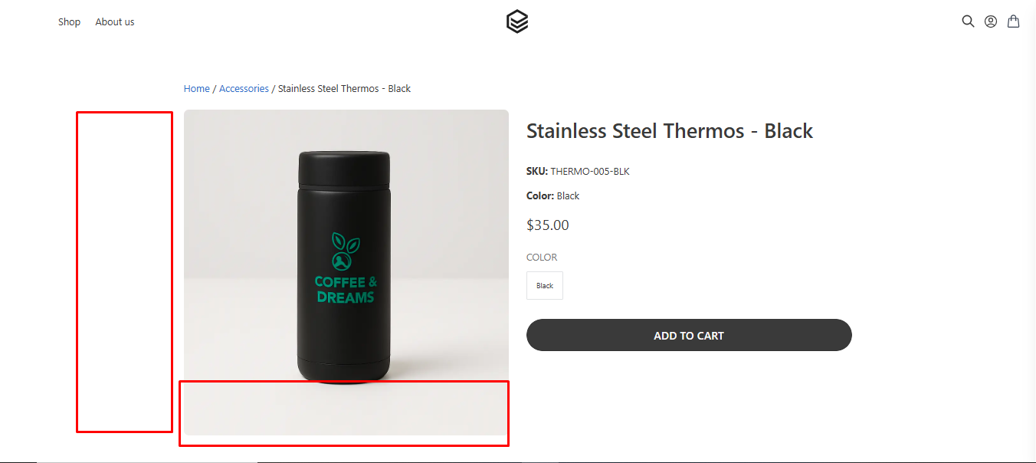

The image should be zoomed after hovering like this. As a result we can see the products in detail.
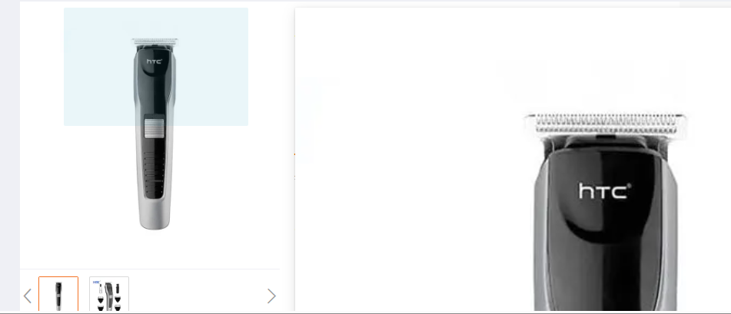

Delivery option, Return & warranty policy and Payment method should be placed in the marked area
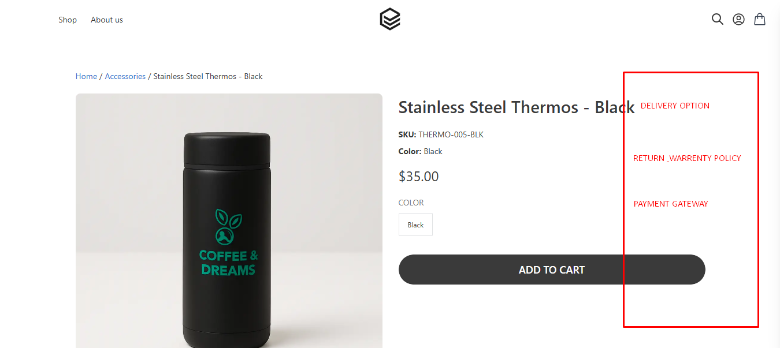

Live chat or question & answer sections can be added on this page. So that customer could make a decision early to buy this product.
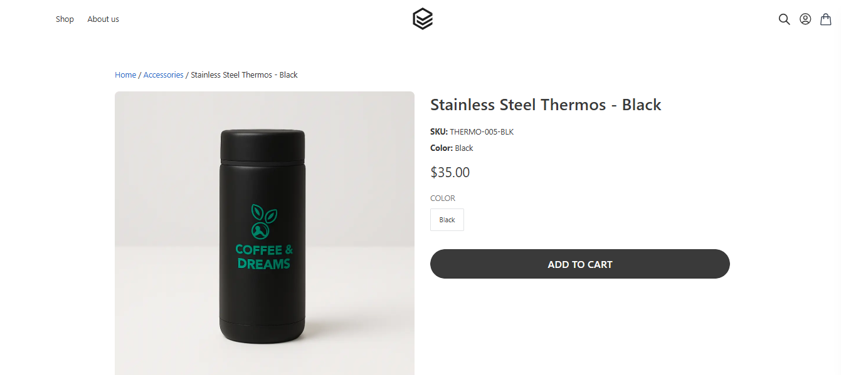

Public review should be added below the description
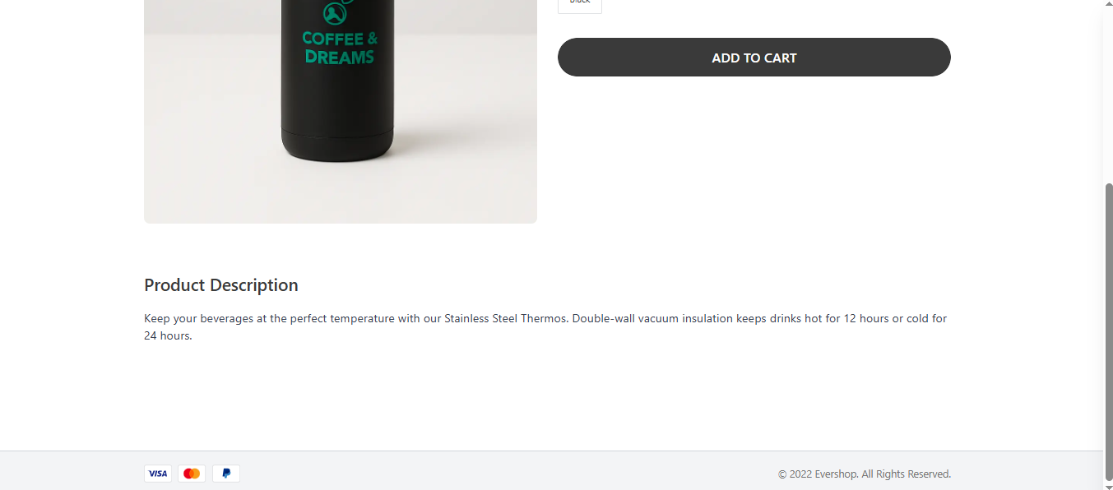

Add to cart button should be more smaller and “Buy Now” button should be added on the right to cart button
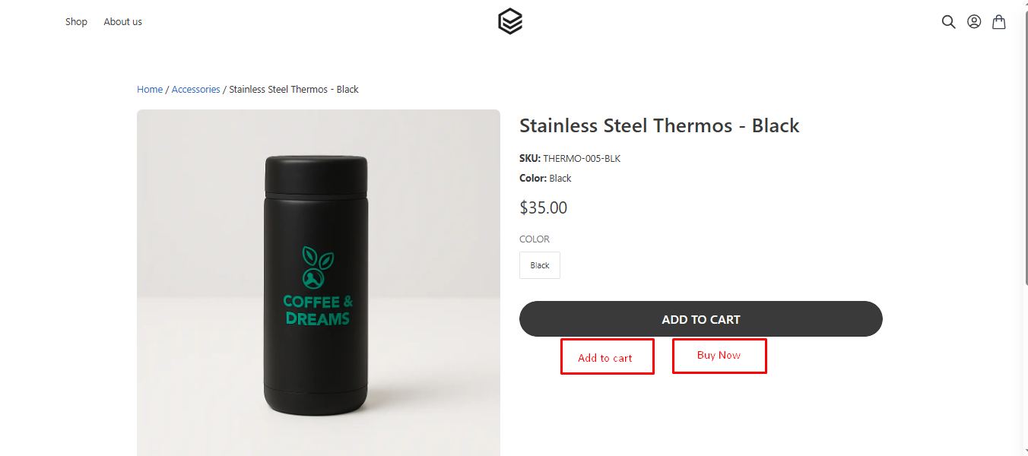

API (Application Programming Interface)

Serial No. | API Name | Method | URL
1 | Stainless steel thermos black | GET | https://demo.evershop.io/accessories/stainless-steel-thermos-black
2 | Stainless steel thermos black  (color black) | GET | https://demo.evershop.io/accessories/stainless-steel-thermos-black?color=2
3 | Cart | GET | https://demo.evershop.io/cart
4 | Checkout | GET | https://demo.evershop.io/checkout
5 | Success Checkout | GET | https://demo.evershop.io/checkout/success/abb6300b-6cec-4b8d-914e-38f9d282b20d

API Test (Postman)

https://mahbubfaisal-cse-8666488.postman.co/workspace/Mahbubul-Islam's-Workspace~0de70dbe-3dd9-48c3-8535-6a30c419f728/collection/51200846-6992a85a-3c77-4051-8883-079500d72d81?action=share&creator=51200846&active-environment=51200846-a8a0a2c3-ee3e-4d30-a2df-8033b0fc5532

